**Background on Human Resources Database Table**

**Table Description and Usage**

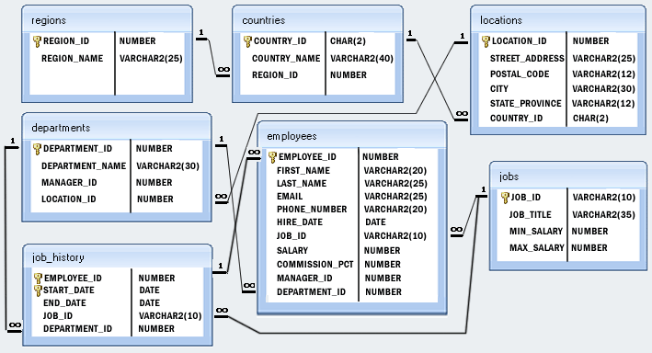

The database supports the storing of employee personal information and other business-critical records such as recruitment, performance, training and benefit records.

The *employees* table is the hub of the database. Each record represents an employee at the company. By extension, the *department* table carries additional information that goes beyond just the department ID, including the name of the department, the manager of that department and where it is based. The *job_history* table provides further specific recruitment-related information of an employee, such as his/her start and end date. Linking with it is also the *jobs* table where further information about the employee’s job is provided to include the job title and the salary range.

The *locations*, *regions* and *countries* tables allow us to drill down further into the geographic situation of an employee’s department.

**Primary and Foreign Keys**

The primary and foreign keys are also depicted in the figure above. Understandably, an employee is related to one department, one job and one job history in the company. But a region could be related to multiple countries, and a country could be related to multiple department locations. A location could have multiple departments, but a department is specific to a location.

All foreign key columns are required, the user thus must enter a valid value according to the specified integrity rules (including referential integrity). For example, when inserting a new row in the *employees* table, the user must know the employee ID.